假设
The annual number of rocket launches is constrained by infrastructure capacity, manufacturing throughput, regulatory limits, and operational resources; therefore, a long-term saturation level exists. Early expansion of launch frequency is driven by scale-up and process learning and is approximately exponential, while growth slows as the system approaches capacity limits, resulting in an S-shaped growth pattern. Multiple drivers of launch growth (reusability, production ramp-up, launch site expansion, and operational efficiency) are captured by a single effective growth rate parameter 𝑟. The model operates on a yearly time scale and represents long-term expected launch activity, ignoring short-term scheduling fluctuations.
公式
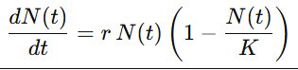
N(t)：从起始年𝑡0起累计到𝑡的发射总次数
dN(t)/dt：年发射率
𝐾：长期饱和的累计发射上界
𝑟：增长率
推导得
